

# 

### Semester One Examination, 2020

### Question/Answer booklet

# MATHEMATICS

If required by your examination administrator, please place your student identification label in this box

**SPECIALIST**

**UNIT 1**

## Section Two:

## Calculator-assumed

|  |  |  |  |  |  |  |  |  |  |  |
| --- | --- | --- | --- | --- | --- | --- | --- | --- | --- | --- |
| WA student number: In figures |  |  |  |  |  |  |  |  |  |  |

In words

Your name

|  |  |
| --- | --- |
| Number of additional answer booklets used (if applicable): |  |

## Time allowed for this section

Reading time before commencing work: ten minutes

Working time: one hundred minutes

## Materials required/recommended for this section

***To be provided by the supervisor***

This Question/Answer booklet

Formula sheet (retained from Section One)

***To be provided by the candidate***

Standard items: pens (blue/black preferred), pencils (including coloured), sharpener,  
correction fluid/tape, eraser, ruler, highlighters

Special items: drawing instruments, templates, notes on two unfolded sheets of A4 paper, and up to three calculators approved for use in this examination

## Important note to candidates

No other items may be taken into the examination room. It is **your** responsibility to ensure that you do not have any unauthorised material. If you have any unauthorised material with you, hand it to the supervisor **before** reading any further.

## Structure of this paper

|  |  |  |  |  |  |
| --- | --- | --- | --- | --- | --- |
| Section | Number of questions available | Number of questions to be answered | Working time (minutes) | Marks available | Percentage of examination |
| Section One: Calculator-free | 8 | 8 | 50 | 52 | 35 |
| Section Two: Calculator-assumed | 13 | 13 | 100 | 98 | 65 |
|  | | |  | **Total** | 100 |

|  |  |  |
| --- | --- | --- |
| Markers use only | | |
| Question | Maximum | Mark |
| 9 | 6 |  |
| 10 | 5 |  |
| 11 | 8 |  |
| 12 | 8 |  |
| 13 | 7 |  |
| 14 | 8 |  |
| 15 | 8 |  |
| 16 | 7 |  |
| 17 | 9 |  |
| 18 | 8 |  |
| 19 | 8 |  |
| 20 | 8 |  |
| 21 | 8 |  |
| S2 Total | 98 |  |
| S2 Wt (×0.6633) | 65% |  |

## Instructions to candidates

1. The rules for the conduct of examinations are detailed in the school handbook. Sitting this examination implies that you agree to abide by these rules.

2. Write your answers in this Question/Answer booklet preferably using a blue/black pen.  
Do not use erasable or gel pens.

3. You must be careful to confine your answers to the specific question asked and to follow any instructions that are specific to a particular question.

4. Show all your working clearly. Your working should be in sufficient detail to allow your answers to be checked readily and for marks to be awarded for reasoning. Incorrect answers given without supporting reasoning cannot be allocated any marks. For any question or part question worth more than two marks, valid working or justification is required to receive full marks. If you repeat any question, ensure that you cancel the answer you do not wish to have marked.

5. It is recommended that you do not use pencil, except in diagrams.

6. Supplementary pages for planning/continuing your answers to questions are provided at the end of this Question/Answer booklet. If you use these pages to continue an answer, indicate at the original answer where the answer is continued, i.e. give the page number.

7. The Formula sheet is not to be handed in with your Question/Answer booklet.

Section Two: Calculator-assumed 65% (98 Marks)

This section has**thirteen** questions. Answer **all** questions. Write your answers in the spaces provided.

Working time: 100 minutes.

Question 9 (6 marks)

Determine the size of the angles marked $a, b, c, d, e$ and $f$ shown in the circles below. Where marked, $O$ is the centre of the circle.

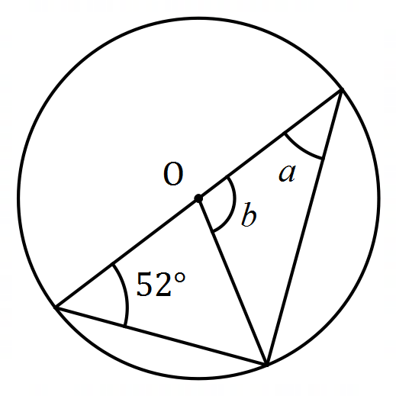 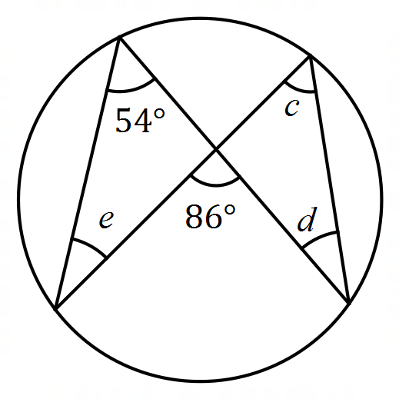 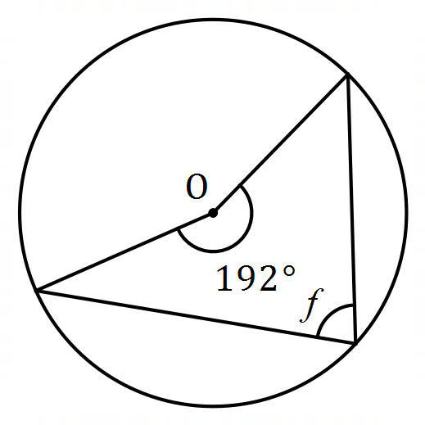

Question 10 (5 marks)

Three forces act on an object so that it remains in equilibrium. Two of the forces have magnitudes of $80$ N and $110$ N and the angle between their directions is $105°$. Determine the magnitude of the third force and the angle its direction makes with the smaller force.

Question 11 (8 marks)

(a) An art gallery plans to display a single painting on each of the three walls in a room. Determine how many arrangements of paintings are possible in the room if they have a selection of $24$ different paintings to choose from. (2 marks)

(b) In another room, the gallery plan to hang $8$ different paintings in a row. If $2$ of the paintings are by the artist Marr, determine the number of different arrangements of paintings that are possible when

(i) the paintings by Marr must be at the ends. (2 marks)

(ii) the paintings by Marr must be next to each other. (2 marks)

(iii) the paintings by Marr must be apart and not at the ends. (2 marks)

Question 12 (8 marks)

(a) Prove that chords of equal length subtend equal angles at the centre of a circle.

(3 marks)

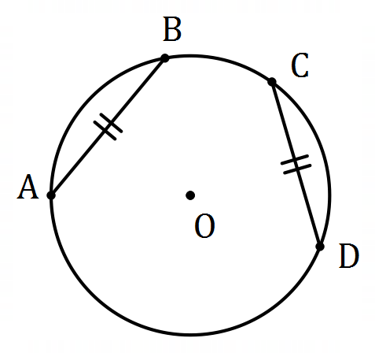

(b) Points $P$ and $Q$ lie on a circle of radius $23.3$ cm so that $PQ=21$ cm. Determine

(i) the distance of chord $PQ$ from the centre of the circle. (3 marks)

(ii) the angle subtended by chord $PQ$ at the centre of the circle. (2 marks)

Question 13 (7 marks)

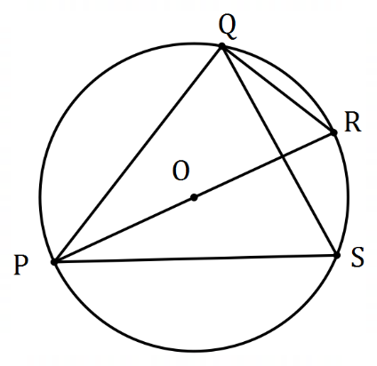(a) The diagram shows points $P, Q, R$ and $S$ that  
lie on the circumference of a circle centre $O$. $PR$ 
 is a diameter and the size of $∠QPR=27°$.

Determine, with reasons, the size of $∠PSQ$. (3 marks)

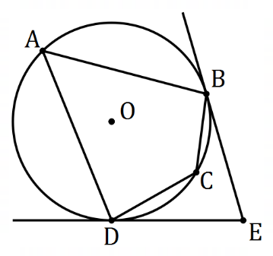

(b) In the diagram shown, $A, B, C$ and $D$ are points  
on the circumference of a circle with centre $O$.

Tangents to the circle at $B$ and $D$ intersect at $E$.

Determine, with justification, the size of $∠BCD$  
when $∠BED=72°$. (4 marks)

Question 14 (8 marks)

In quadrilateral $OPQR$ shown below, $M$ lies on $QR$ so that $\left|\vec{QM}\right|=3|\vec{MR}|$.

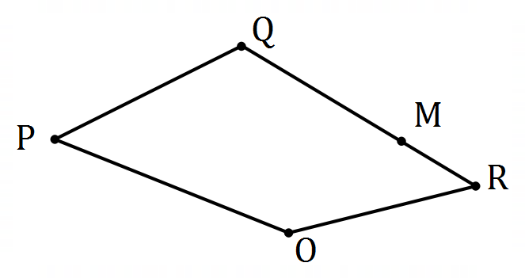

(a) If $\vec{OP}=p, \vec{OQ}=q$ and $\vec{OR}=r$, express the following in terms of $p, q$ and/or $r$.

(i) $\vec{PR}$. (1 mark)

(ii) $\vec{RM}$. (2 marks)

(iii) $\vec{PM}$. (2 marks)

(b) If $O$ is the origin and points $P, Q$ and $R$ have coordinates $\left(-2, 39\right), (28, -14)$ and $(32, -18)$ respectively, determine the distance $PM$. (3 marks)

Question 15 (8 marks)

(a) The vertices of quadrilateral $ABCD$ lie on the circumference of a circle centre $O$ shown below. Given that $∠ADC=95°$ and $∠AOB=84°$, determine with reasoning the size of angle $BCO$. (4 marks)

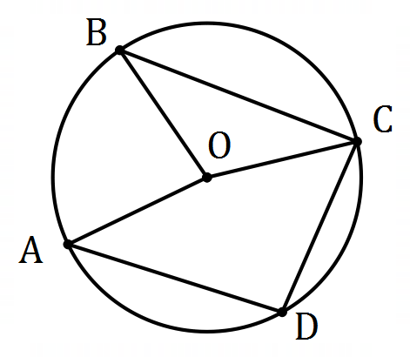

(b) The vertices of triangle $ABC$ lie on the circumference of a circle. Given that $AB=10$ cm, $AC=7$ cm and $BC=6$ cm, prove by contradiction that $AB$ is not a diameter of the circle.

(4 marks)

Question 16 (7 marks)

(a) A calculator can generate random integers between $10$ and $25$. Use the pigeonhole principle to explain why $49$ random integers should be generated to be certain that at least $4$ of them are the same. (3 marks)

(b) $16$ customers bought a total of $130$ items from a supermarket. Given that each customer bought at least one item, show that at least two of the customers bought the same number of items. (4 marks)

Question 17 (9 marks)

(a) Determine the scalar product of

(i) $3.5i+6.5j$ and $8i-2j$. (1 mark)

(ii) two vectors with directions $60°$ apart that have magnitudes of $15$ and $18$. (1 mark)

(b) Given that $\left|a\right|=3$ and $\left|b\right|=7$ simplify $\left(a+b\right)⋅\left(a+b\right)+a⋅(a-2b)$. (3 marks)

(c) The position vectors of points $P, Q$ and $R$ are $\left(\begin{matrix}3 \\ -2\end{matrix}\right), \left(\begin{matrix}-2 \\ -1\end{matrix}\right)$ and $\left(\begin{matrix}-5 \\ 3\end{matrix}\right)$. Show use of a vector method to determine the size of angle $PQR$. (4 marks)

Question 18 (8 marks)

A school yearbook is produced by a committee of $3$ teachers and $8$ students. $5$ teachers and $17$ students have nominated for the committee.

(a) Determine how many different committees could be formed from the nominations.

(2 marks)

(b) The student nominations include two sets of twins. Determine how many different committees could be chosen that include at least one set of twins. (4 marks)

(c) Suppose one of the teachers in the committee will be appointed as treasurer and one of the students will be appointed as secretary. Determine how many different committees can be formed with this structure. (2 marks)

Question 19 (8 marks)

Oil platform T lies $66.5$ km away from another oil platform F on a bearing of $215°$. A steady current of $4.5$ km per hour flows between the platforms on a bearing of $110°$. A small boat at F, with a cruising speed of $12$ km per hour, needs to arrive at T by $4$ pm.

Determine the bearing that the boat should steer and the latest time it should depart from F.

Question 20 (8 marks)

Circles $C_{1}$ and $C_{2}$ intersect at points $P$ and $Q$. $C_{1}$ passes through $O$, the centre of $C_{2}$. $R$ lies on $C_{2}$ so that line segment $RS$ is tangential to $C_{1}$ at $Q$. Let $∠PRQ=α$.

(a) Sketch a diagram to show the above information. (3 marks)

(b) Determine $∠POQ$ in terms of $α$. (1 mark)

(c) Explain why $∠PQS=2α$. (1 mark)

(d) Prove that $PQ=QR$. (3 marks)

Question 21 (8 marks)

Particle $A$, initially at the point with position vector $42i-25j$ cm, moves with a constant velocity of $-8i+15j$ cm/s. Particle $B$ is stationary at the point with position vector $-35i+11j$.

(a) Determine the initial distance of $A$ from $B$. (2 marks)

(b) Determine an expression for the distance $d$ between $A$ and $B$ after $t$ seconds. (3 marks)

(c) Sketch a graph of $d$ against $t$ and hence determine the time that minimises $d$ and state what this minimum distance is. (3 marks)

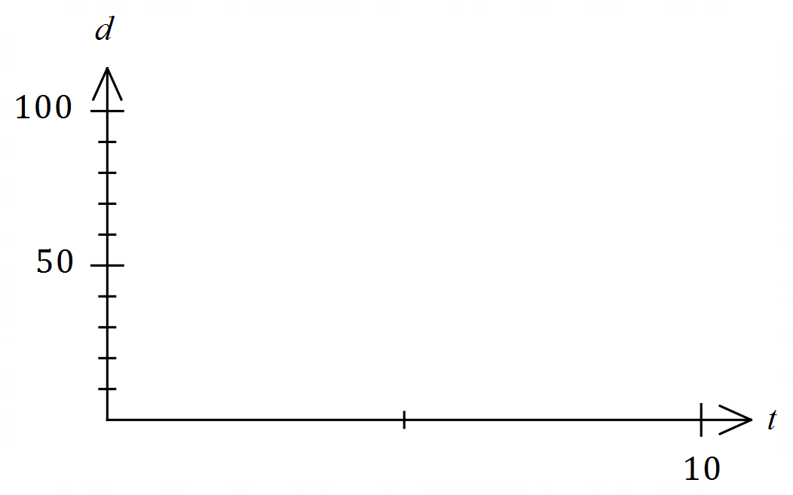

Supplementary page

Question number: _________

Supplementary page

Question number: _________

Supplementary page

Question number: _________

Supplementary page

Question number: _________

© 2020 WA Exam Papers. Baldivis Secondary College has a non-exclusive licence to copy and communicate this document for non-commercial, educational use within the school. No other copying, communication or use is permitted without the express written permission of WA Exam Papers. SN261-151-2.